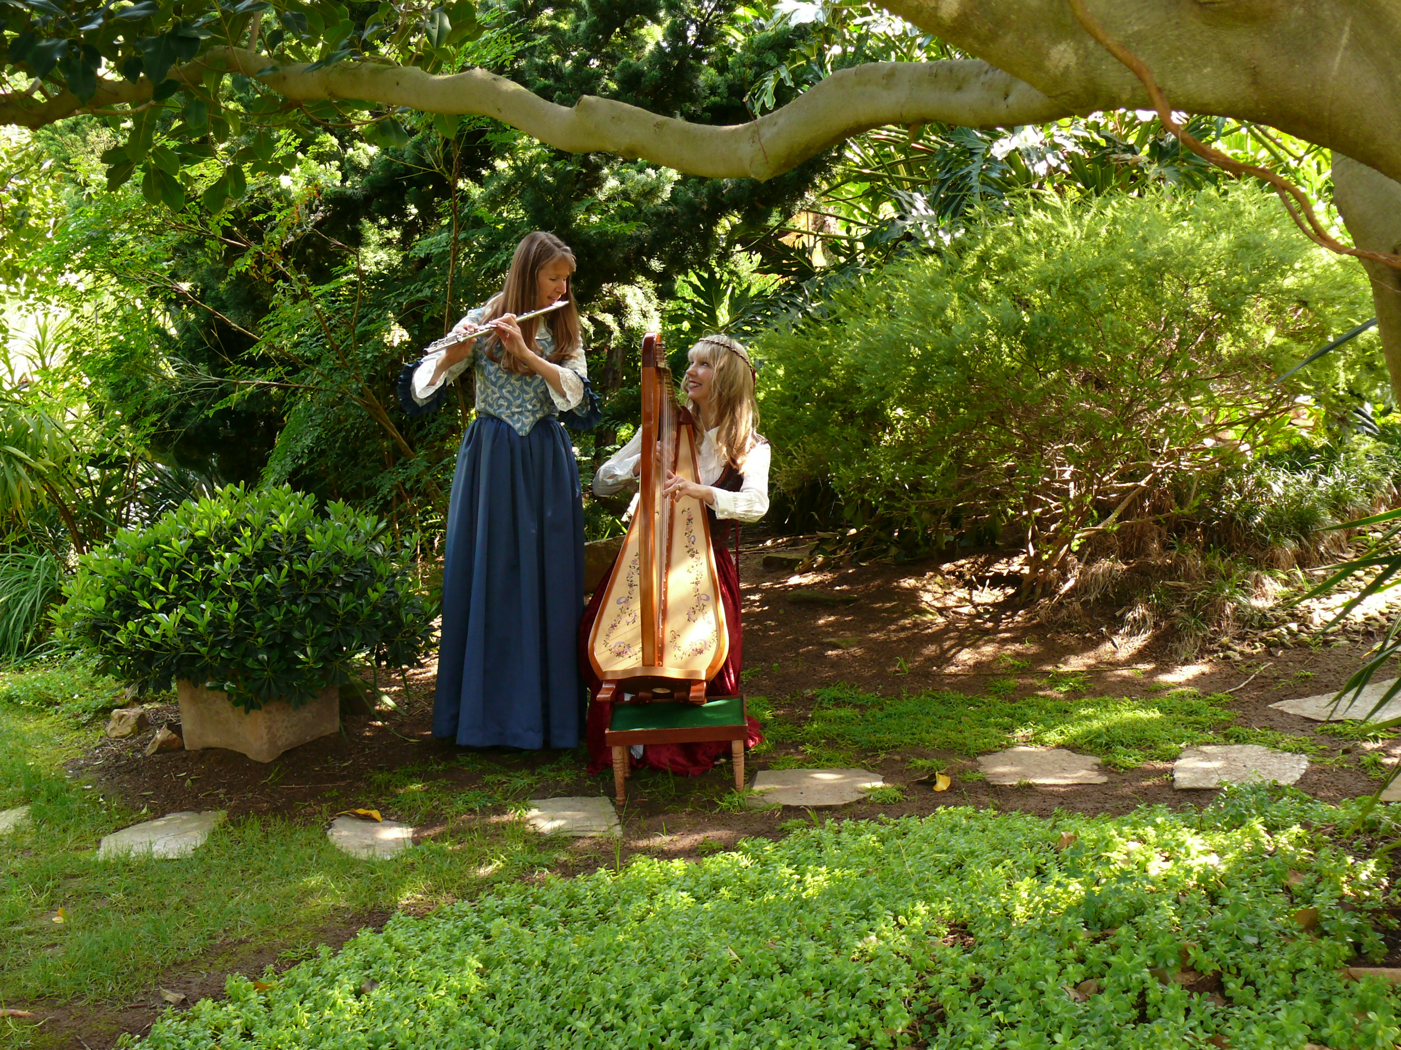

Willowood
Sheila Jaffe, Celtic Harp
Kathy Link, Flute

Both Sheila and Kathy have been playing music since childhood, and in 2001 they combined their musical energies to form Willowood, a harp and flute duo. They play a wide variety of music, creating their own arrangements of Celtic, Renaissance, classical, traditional, and original songs. Together they perform for garden parties, weddings, and other gala social functions. Some of their performance venues include the La Jolla Festival for the Arts, the San Diego Botanic Gardens, and the San Diego Children’s Hospital Celebration of Life ceremony. In addition to playing professionally, they perform frequently at benefit concerts and church events. Their CD All in a Garden Green features a representative selection of their music—both joyous and relaxing.

Sheila, originally a professional keyboard artist and singer in the Pacific Northwest, performed with the Seattle Symphony and for the Classic King FM Summer Concert Series. Along with the musical duo Affinity she was commissioned to create music for “The Floating Opera”, which was commissioned by the Seattle Arts Commission. While in Seattle she also began playing the harp, and is now a much sought-after harpist. Sheila has been featured on a number of recordings and continues to play extensively in a wide variety of venues--from the Carlsbad Marathon to Mother’s Day teas.

Kathy, who lived for many years in Alaska, began her musical career as a classical musician, playing flute in the Fairbanks Symphony Orchestra and Arctic Chamber Orchestra. She later sang and played flute in a guitar/flute duo at weddings and in restaurants. After moving to the San Diego area, she has played with many local musicians and has appeared as a guest musician on several recordings. For many years, she taught and arranged music for a small private elementary school.

Website for CD sales: www.cdbaby.com

For booking information contact: Sheila Jaffe (760) 522-9032 e-mail: sheilaharpist@gmail.com

